GOVERNMENT SIDDHA MEDICAL COLLEGE
PALAYAMKOTTAI
DEPARTMENT OF POTHU MARUTHUVAM
CME REPORT
Month: February 2026

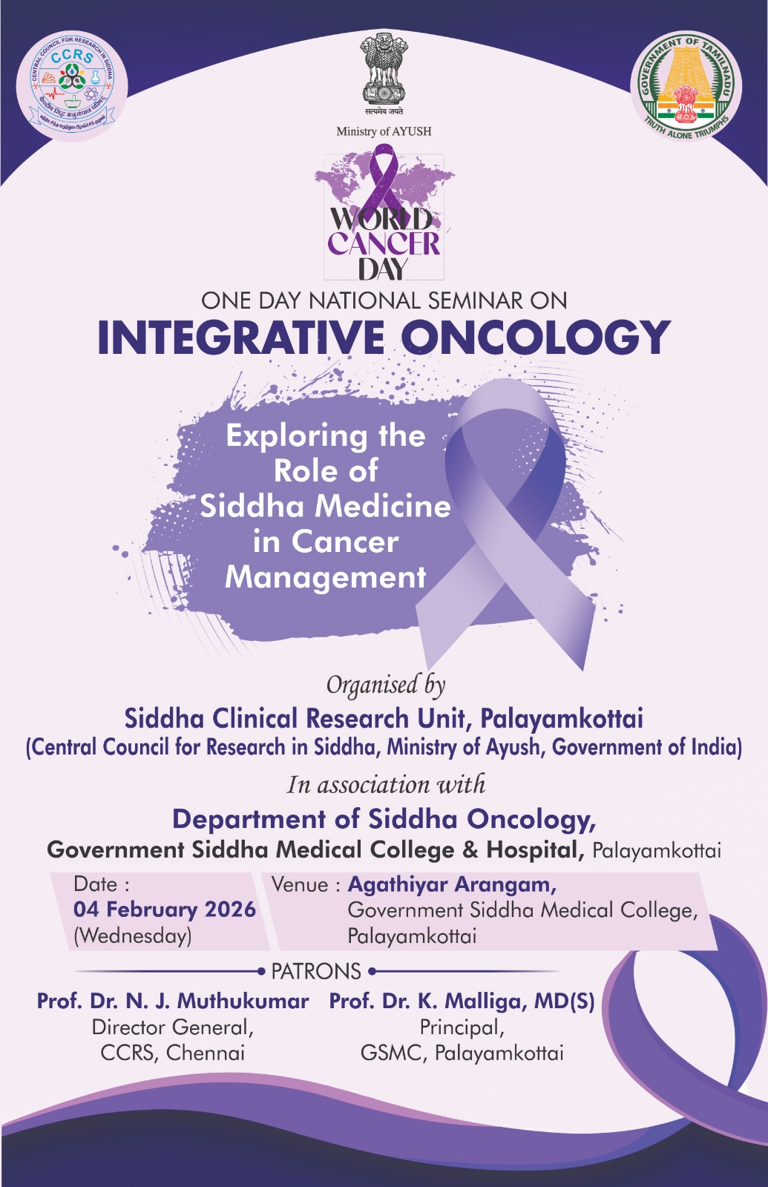
INAUGURAL SESSION:
The programme commenced with the inaugural session.
- Welcome Address was delivered by Prof. Dr. S. Justus Antony, MD(S), Department of Pothu Maruthuvam, GSMC, Palayamkottai.
- Presidential Address was given by Prof. Dr. K. Malliga, MD(S), Principal, GSMC, Palayamkottai, highlighting the importance of integrative approaches in cancer care and research.
- Inaugural Address was rendered by Dr. G. Esakki Pandian, MD(S), Vice Principal, GSMC, Palayamkottai.
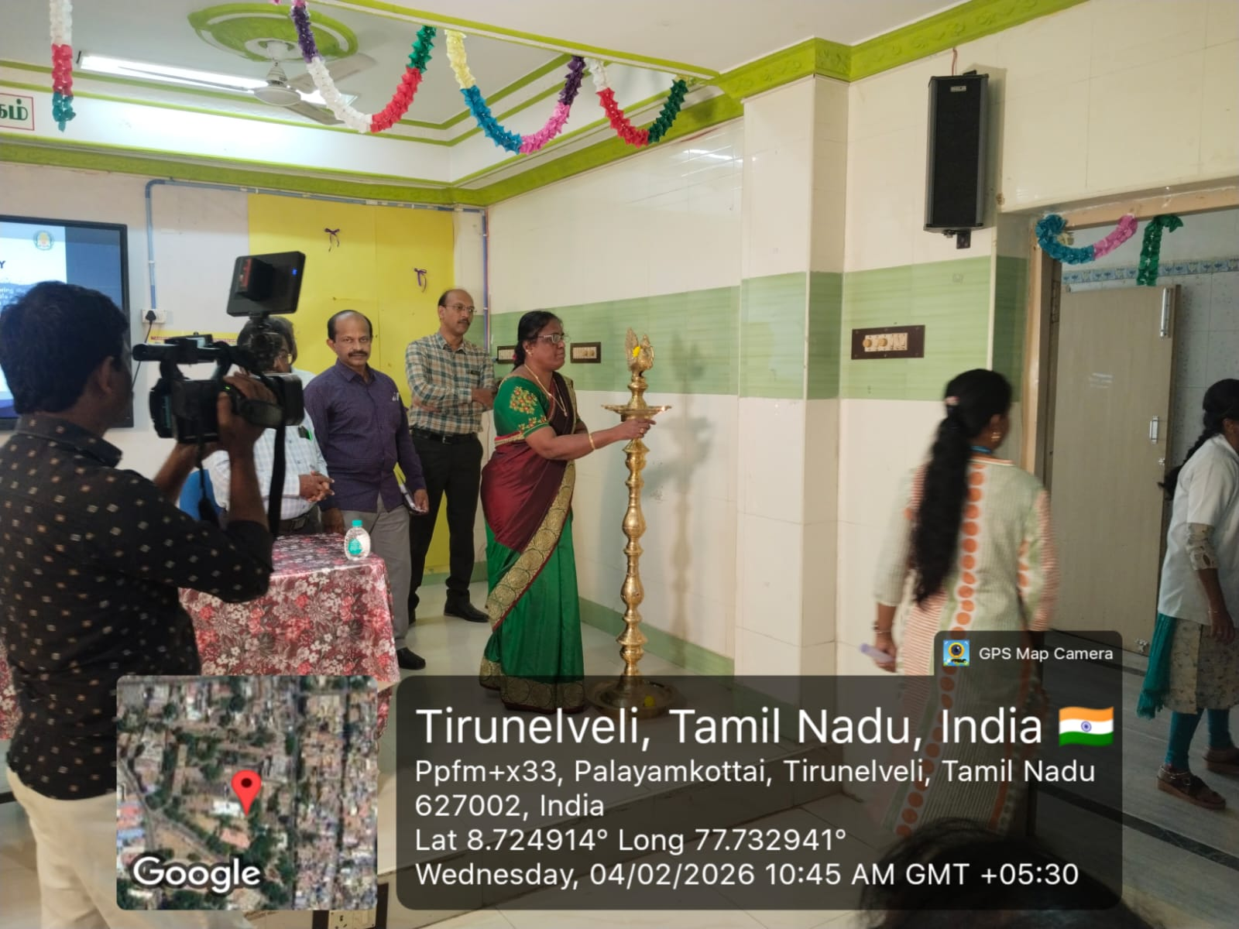
- Felicitations were offered by
  - Dr. Muruganandam, MBBS, MD, DMRD,
  - Dr. M. Ganesh Babu, MD(S), Resident Medical Officer, and
  - Dr. G. Subash Chandran, MD(S), Ph.D, Associate Professor, Department of Pothu Maruthuvam.
The session concluded with the Vote of Thanks proposed by Dr. M. Harihara Mahadevan, MD(S), Research Officer (Siddha) & Scientist-II, Siddha Clinical Research Unit, Palayamkottai.
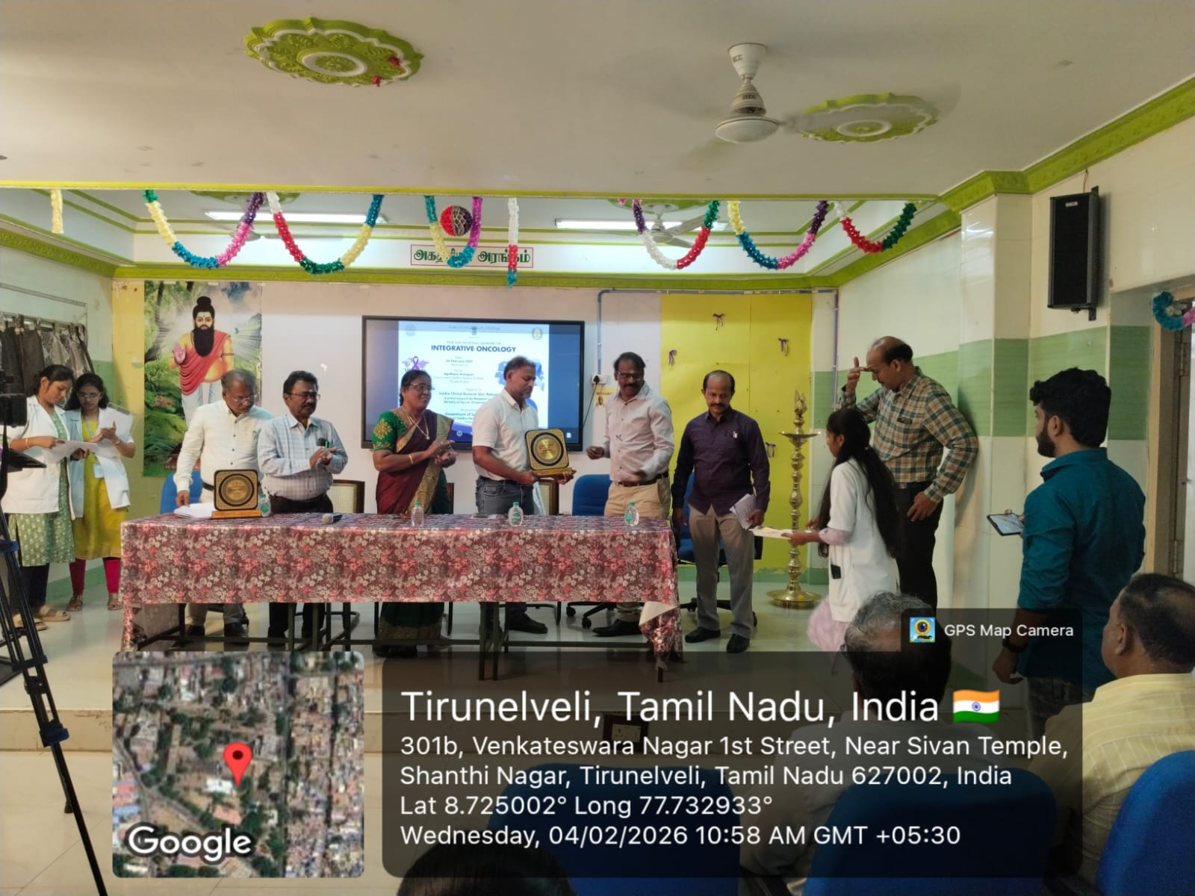
Expert Talk (11.30 AM – 12.15 PM)
Topic: Recent Advances in Cancer Treatment
Speaker: Dr. Mohammed Ibrahim, MBBS, MS, DNB, MRCSed (UK), FEBS (Belgium), FIAGES, FMAS, FAIS, FCGP, Consultant Surgical Oncologist.
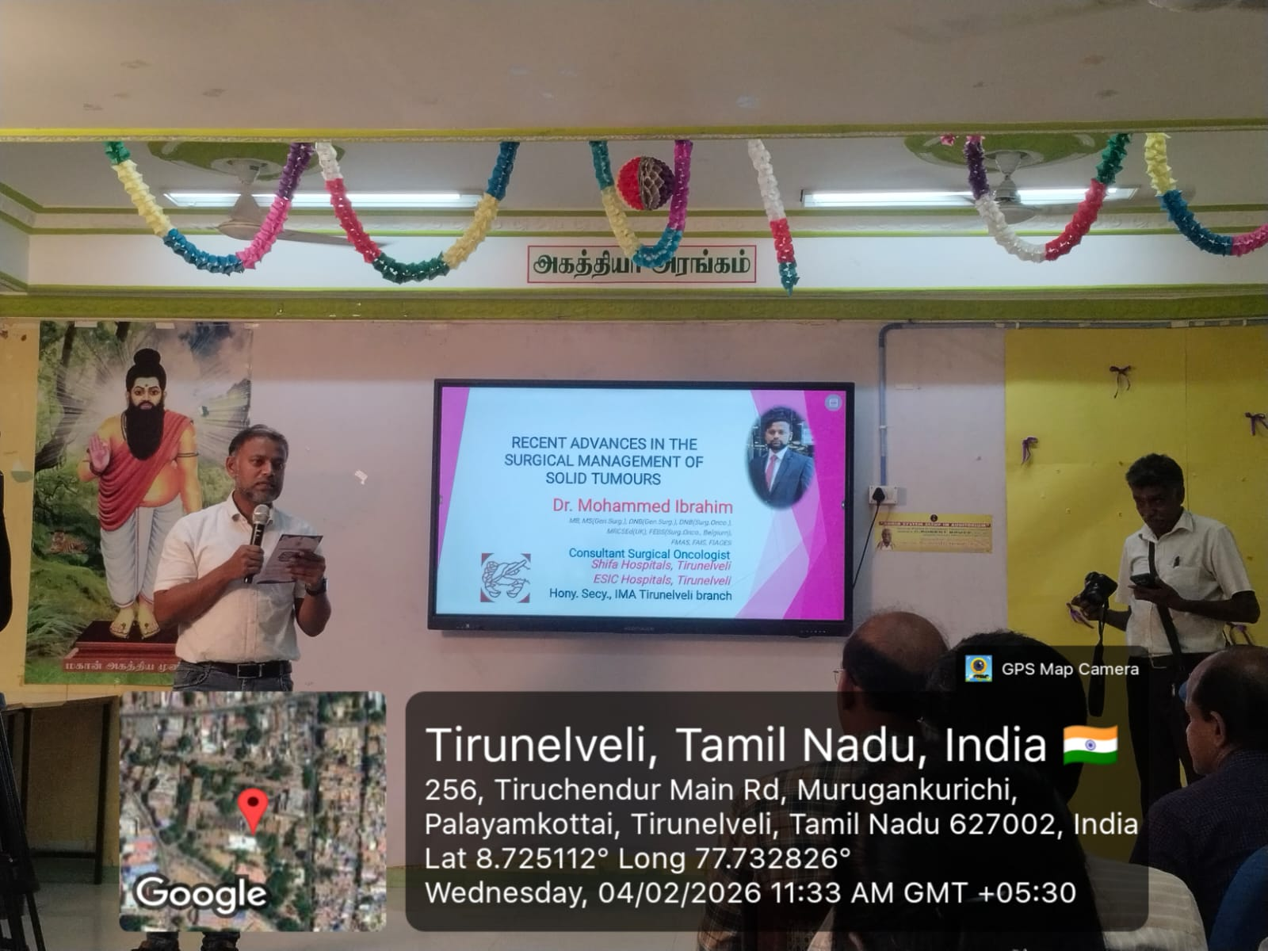
Scientific Presentation (12.15 PM – 1.00 PM)
Topic: Integrative Oncology in Practice: Siddha and Modern Perspectives
Speakers: PG Scholars
Dr. P. Kantha Meena,
Dr. A. E. Priyadharshini,
Dr. R. Noorul Hasina,
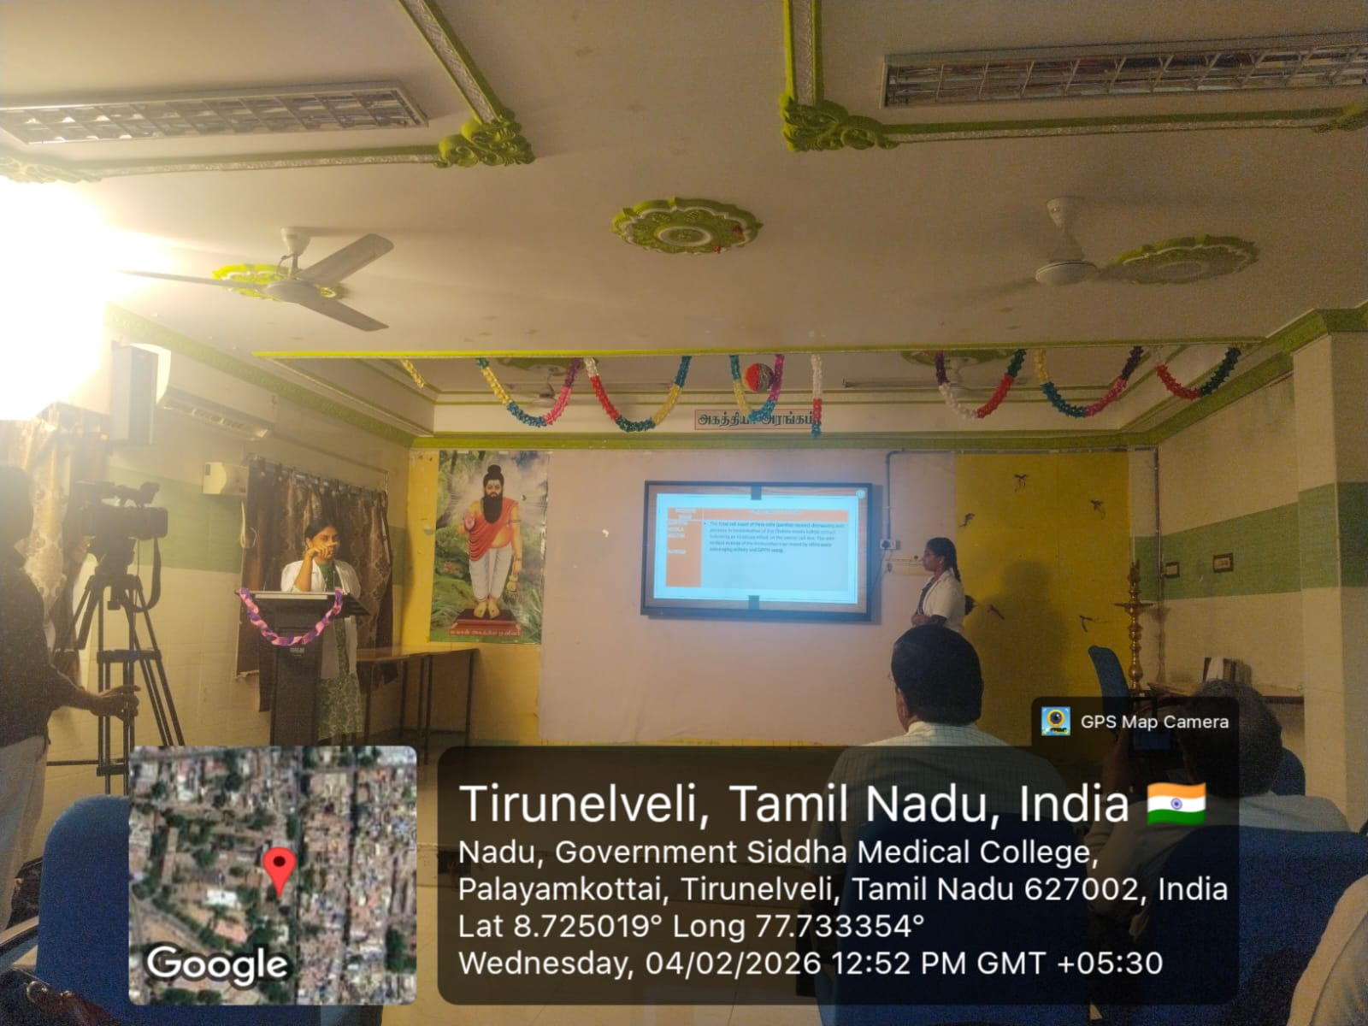
Afternoon Session
Expert Talk (2.15 PM – 3.00 PM)
Topic: The Role of Integrated Medicine in Oncological Practice
Speaker: Dr. S. Shanmugam, MD, Senior Physician, Diabetologist & Freelance Siddha Researcher.
Expert Talk (3.00 PM – 3.45 PM)
Topic: Siddha Oncology Research – A Roadmap
Speaker: Dr. M. Harihara Mahadevan, MD(S), Research Officer (Siddha) & Scientist-II.
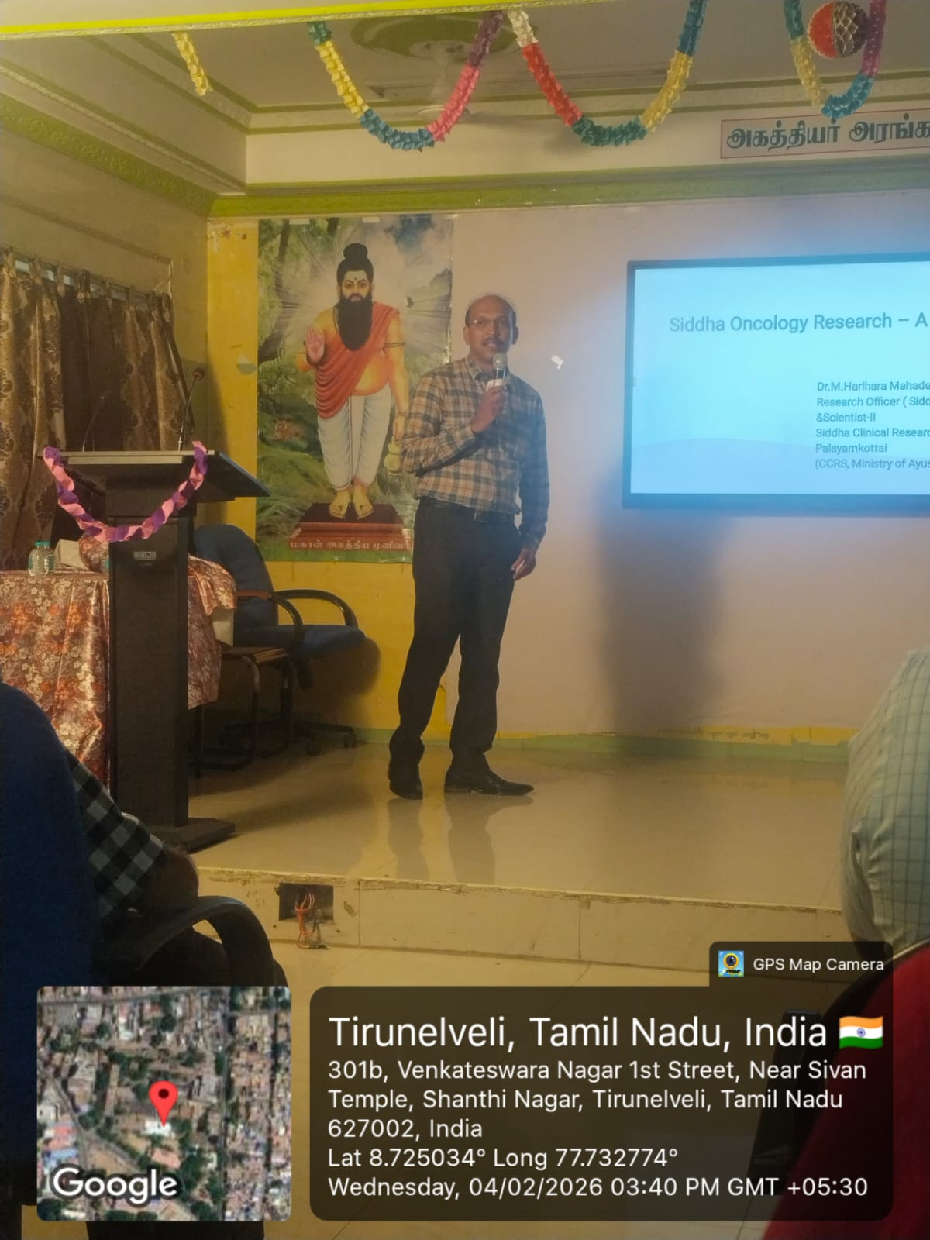

Scientific Presentation:
Topic: Therapeutic Potential of Kayakarpam in Cancer Management
Speakers: PG Scholars:
Dr. M. Harini Subhashine,
Dr. N. U. Ramya,
Dr. K. S. Supriya,
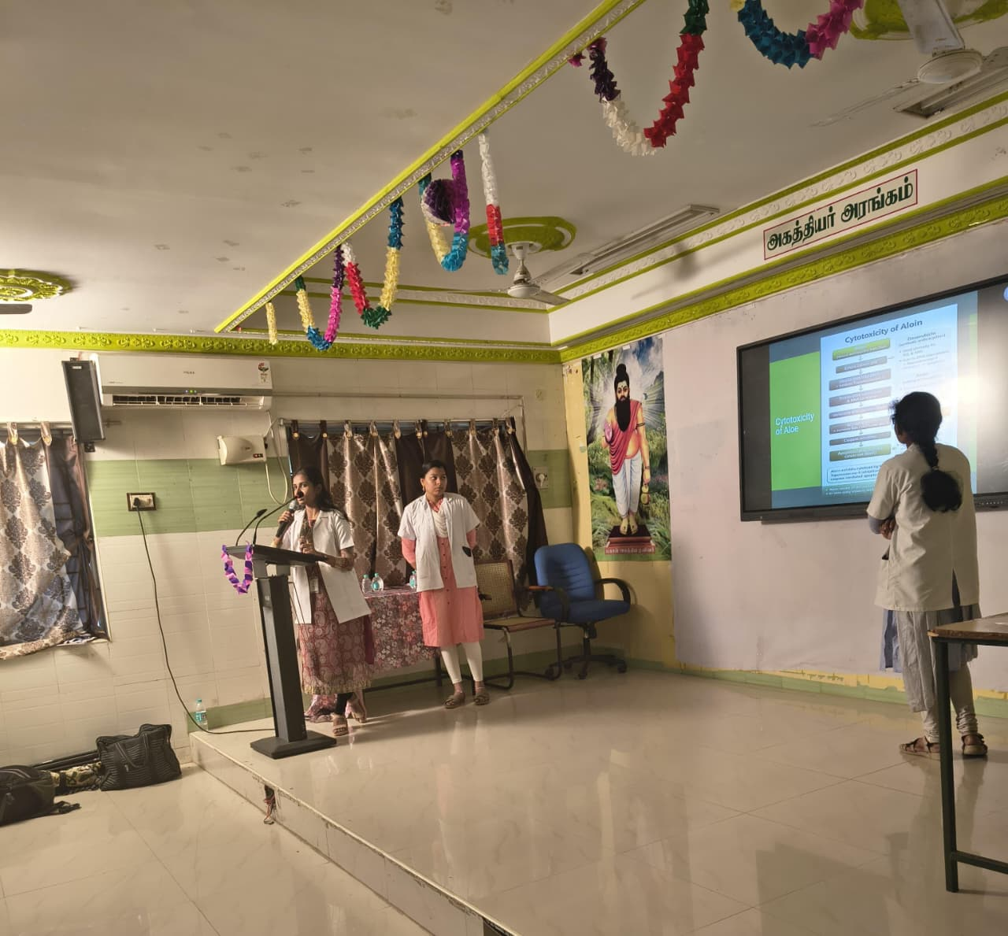

Participants Feedback:
The students expressed satisfaction with the scientific programme. The sessions were considered academically enriching, clinically relevant, and highly informative. The integration of Siddha principles with modern oncology was particularly appreciated for its practical applicability in contemporary healthcare settings.

