DEPARTMENT OF SOOL AND MAGALIR MARUTHUVAM
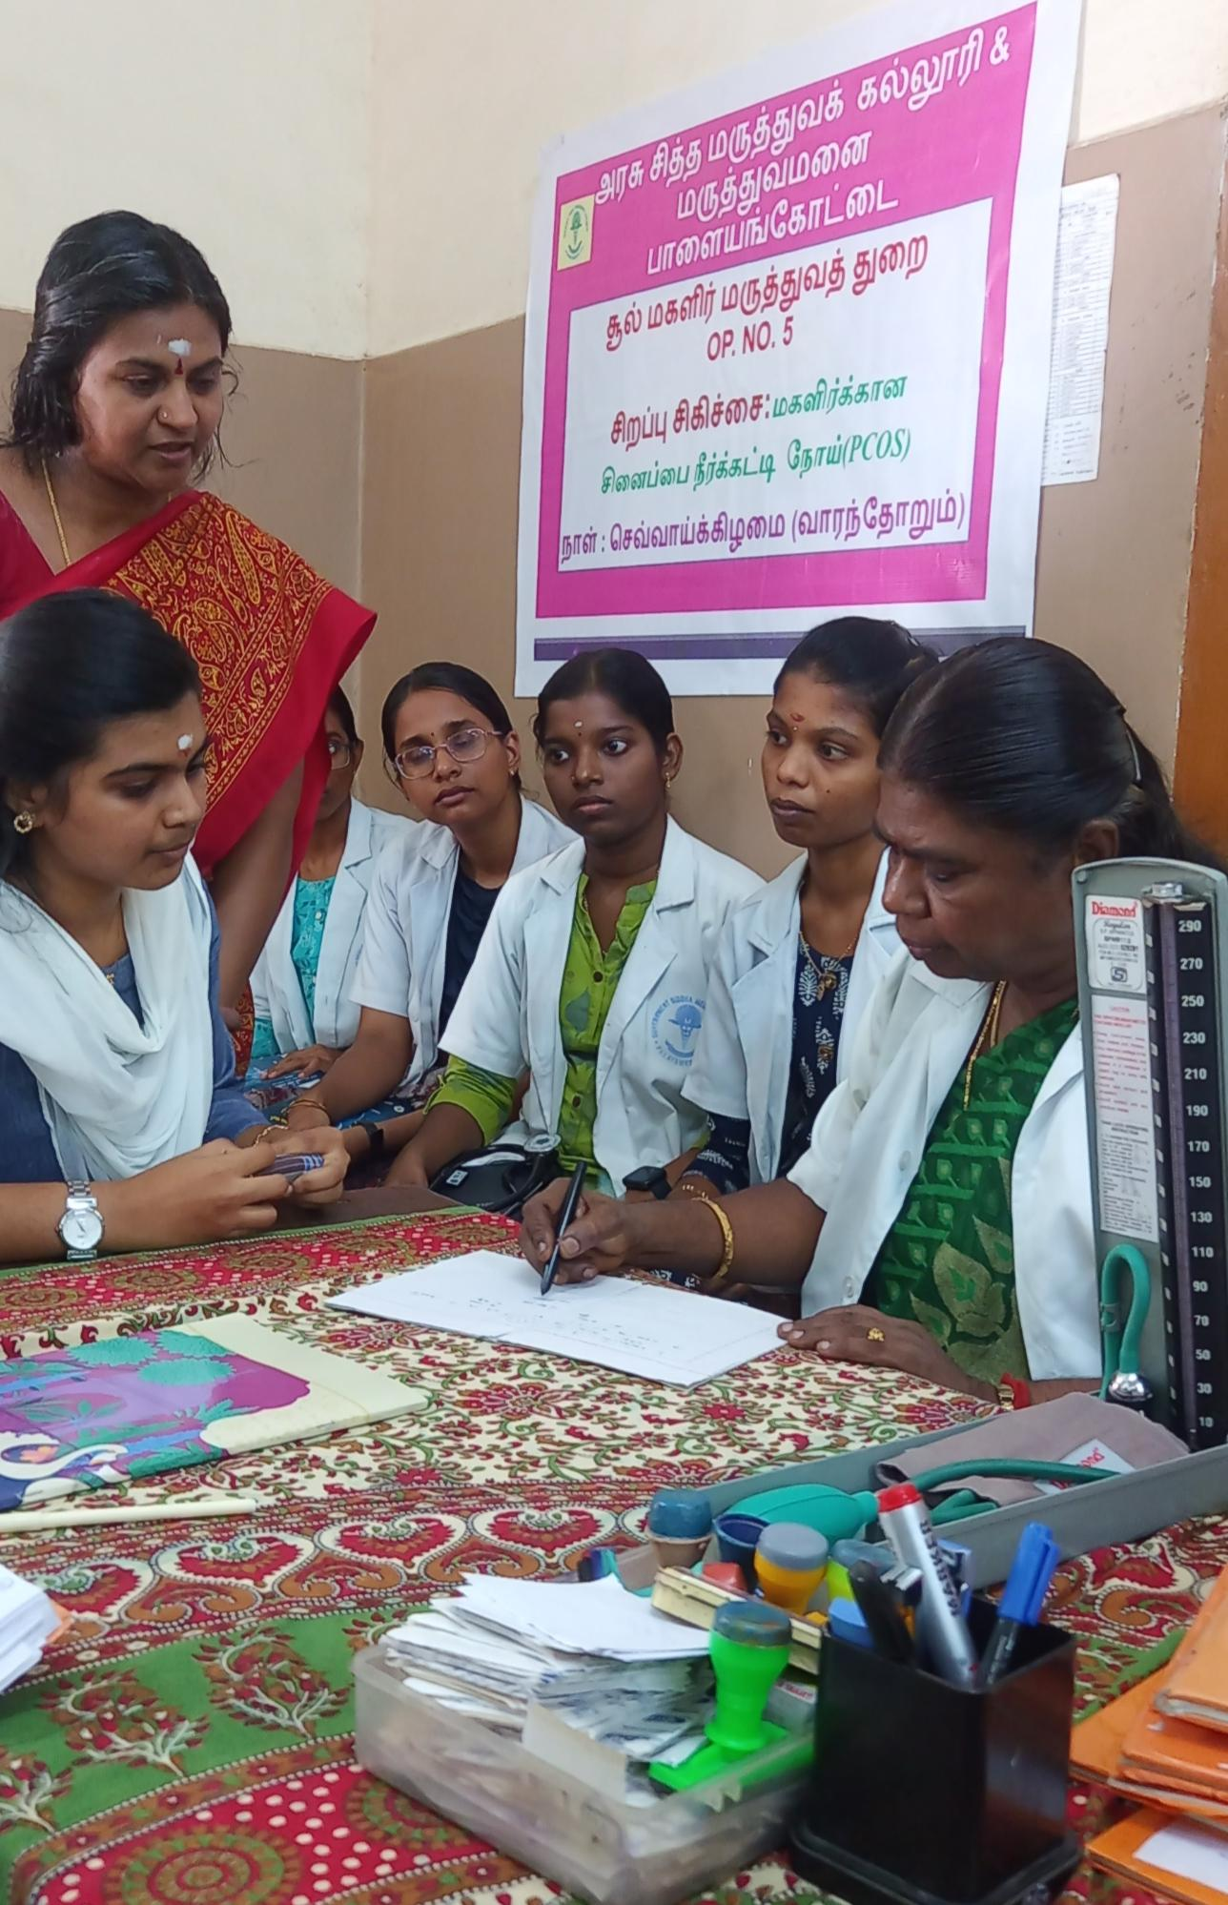

DR. K. N. VIJAYA M.D
HOD, SOOL & MAGALIR MARUTHUVAM UG

CONSULTANTS:
1.Dr. T. MAHARASI MANISELVI M.D– ASSOCIATE PROFESSOR
2.Dr.S. SUJATHA M. D – LECTURER GRADE II

TREATED DISEASES :
1.SOOTHAGA VALI (DYSMENORRHEA )
2.VELLAI (LEUCORRHEA)
3.KARUPPAI ADITHALLAL (UTERINE PROLAPSE)
4.KARUPPAI KALUNDHU THABITHAM ( CERVICITIS)
5.PERUMPAADU (MENORRHAGIA)
6.KARUPPAI KATTI (FIBROID UTERUS)
7. KADAI POOPU KOLARUGAL (POST MENOPAUSAL SYNDROME)

SPECIAL OPS:
1.MONDAY – RATTHA SOGAI (ANAEMIA)
2.TUESDAY – KUZHANDHAIYINMAI (INFERTILITY)
SINAIPPAI NEERKATTI (PCOS)

