PROGRAM REPORT

Event: Pre-IEC: Inter-Institutional Research Discussion
Organized by:Department of Integrative Health and Translational Research, Government Siddha Medical College, Palayamkottai
Date:18/09/2026
Time: 10.30 am to 1.00 pm
Venue: Agathiar Aranga
The Department of Integrative Health and Translational Research, Government Siddha Medical College, Palayamkottai, organized a Pre-IEC: Inter-Institutional Research Discussion on 18th September 2026 at Agathiar Arangam.
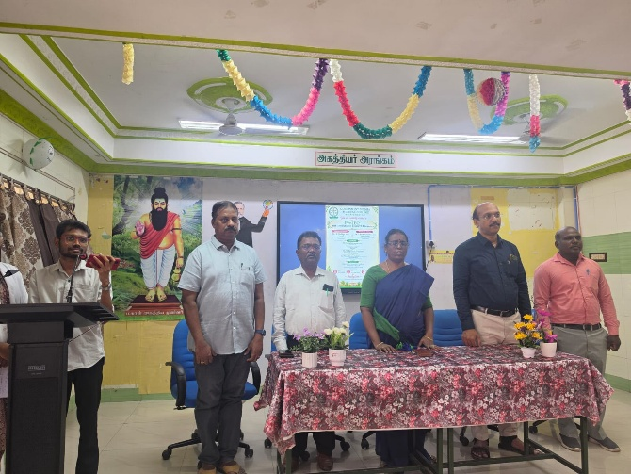
The program commenced with the welcome address delivered by Dr. Thomas Walter, professor,HOD of Department of integrative health and translational research. The Presidential Address was delivered by Dr. K. Malliga, MD(S), Principal, Government Siddha Medical College, Palayamkottai, followed by the Felicitation Address by Dr. G. Essakkypandian, MD(S), Vice Principal, Government Siddha Medical College, Palayamkottai.

Following the addresses, the technical session featured the following speakers:
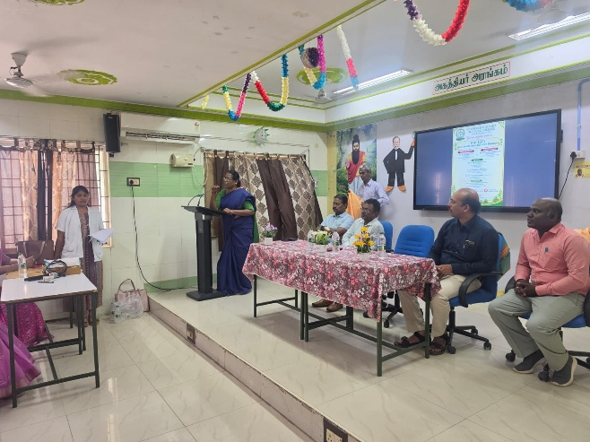

1. Dr. M. Harihara Mahadevan, Research Officer (Siddha) – Scientist, SCRU, Palayamkottai
2. Dr. Paranthaman Subash, M.Pharm., Ph.D., Associate Professor, School of Pharmacy, Joy University, Tirunelveli

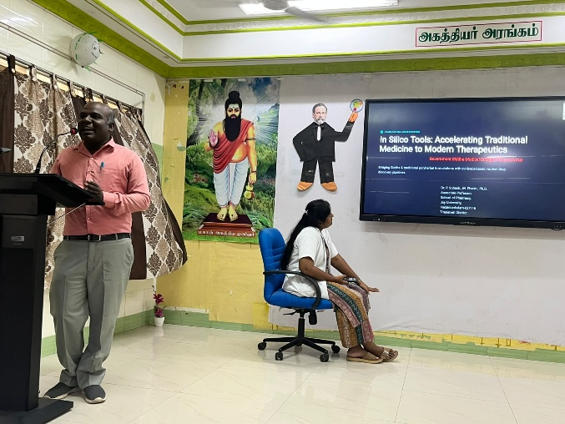
The speakers shared valuable insights and engaged in an inter-institutional research discussion, enriching the participants with diverse research perspectives.
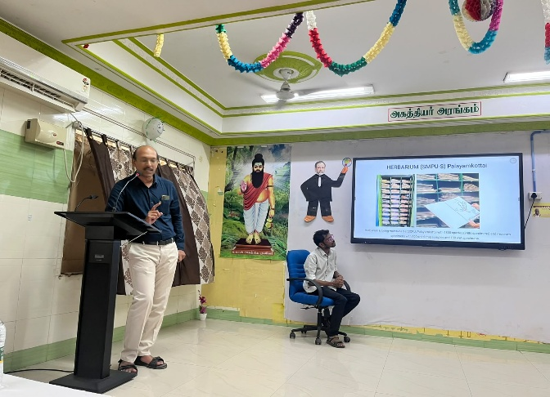
The program concluded with a vote of thanks proposed by Dr. Sulfin nihhar, Professor.

