PROGRAMME REPORT
XVII – INSTITUTIONAL ETHICAL COMMITTEE (IEC) MEETING
Organized by:
Department of Integrative Health and Translational Research
Government Siddha Medical College & Hospital, Palayamkottai, Tirunelveli
Date: 23.09.2026 & 24.09.2026
Time: 10.00 AM to 5.00 PM
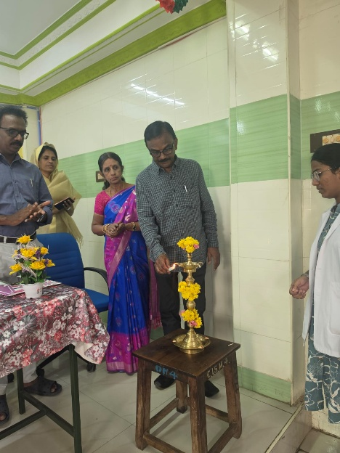
Venue: Agathiar Arangam

- Introduction
The XVII Institutional Ethical Committee (IEC) Meeting of Government Siddha Medical College & Hospital, Palayamkottai, was conducted on 23rd and 24th September 2026 at Agathiar Arangam. The programme was coordinated by the Department of Integrative Health and Translational Research to facilitate the ethical review and discussion of research proposals submitted by postgraduate students and faculty members.

- Inaugural Session
The programme commenced with the Welcome Address delivered by Prof. Dr. M. Thomas Walter, M.D.(S.), Member Secretary, Institutional Ethical Committee.
The Presidential Address was delivered by Prof. Dr. K. Malliga, M.D.(S.), Principal, Government Siddha Medical College & Hospital, Palayamkottai.
The Inaugural Address was delivered by Prof. Dr. S. Mohan, M.D.(S.), Principal (Retd.), Chairperson, Institutional Ethical Committee.
The Felicitation Address was delivered by Prof. Dr. G. Essakky Pandian, M.D.(S.), and the Vote of Thanks was delivered by Prof. Dr. Sulfin Nihar, M.”.(S.).
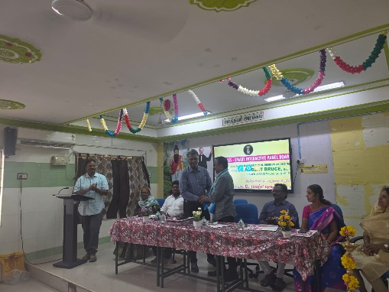
- Institutional Ethical Committee
The XVII IEC comprised a multidisciplinary team with expertise in Siddha medicine, Modern Medicine, Pharmacology, Law, Tamil Research and Counselling.
Chairperson:
Prof. Dr. S. Mohan, M.D.(S.), Principal (Retd.)
Member Secretary:
Prof. Dr. M. Thomas Walter, M.D.(S.)
The committee also included members representing various academic, medical, legal, research and social disciplines.
- Research Protocol Presentations
A total of 56 research proposals were submitted for IEC review. These included:
41 PG dissertation projects
15 faculty/research projects
The research protocols were presented by postgraduate students and faculty members from various departments. The IEC members reviewed and discussed the proposals with respect to ethical considerations, scientific aspects, participant safety, informed consent and other relevant requirements.
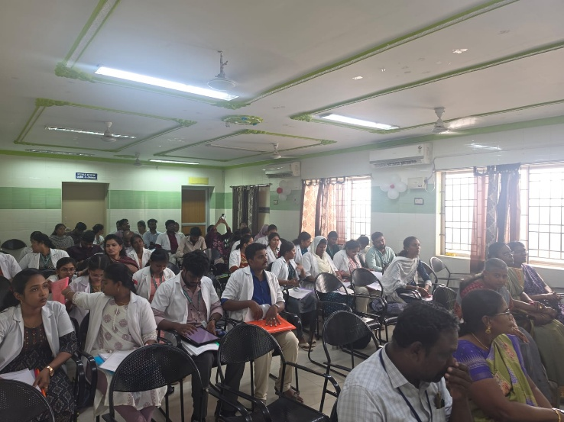
- Role of the Department of Integrative Health and Translational Research
The Department of Integrative Health and Translational Research played a key coordinating role in the successful conduct of the programme. The Department:
Coordinated with the IEC Chairperson, Member Secretary and members.
Coordinated with PG students and faculty investigators.
Facilitated compilation and arrangement of the research proposals.
Coordinated the protocol presentation schedule.
Made necessary venue and logistical arrangements.
Facilitated communication between investigators and IEC members.
Coordinated the documentation of the proceedings.
Initiated necessary follow-up actions based on the observations and recommendations of the IEC.
- Outcome of the Programme
The two-day IEC meeting provided an organized platform for the ethical review and scientific discussion of 56 research proposals. The interaction between the investigators and multidisciplinary IEC members facilitated clarification of ethical and methodological aspects of the proposed research.
The programme was successfully conducted with the active participation and coordination of the IEC members, faculty members and postgraduate students.
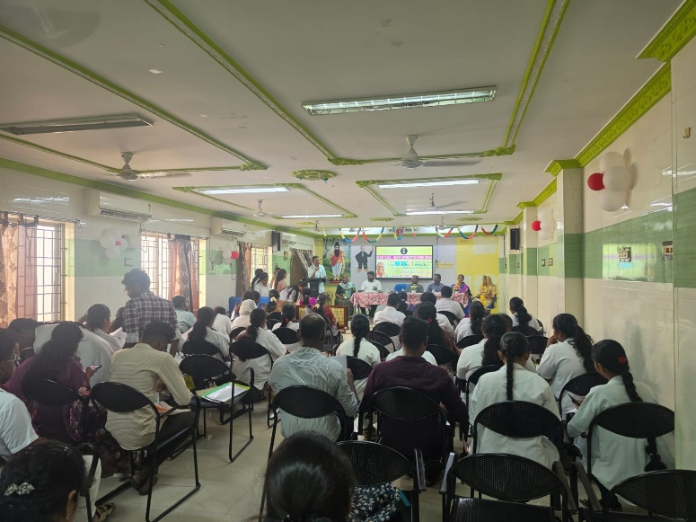
- Conclusion
The XVII Institutional Ethical Committee Meeting was successfully conducted on 23.09.2026 and 24.09.2026 at Agathiar Arangam. The programme strengthened the institutional process of ethical review of research involving human participants and facilitated systematic scrutiny of postgraduate dissertation and faculty research proposals.
The Department of Integrative Health and Translational Research coordinated the programme and maintained the relevant records and proceedings for institutional documentation and further necessary action.

